POLICIES AND PROCEDURES

FIN.SOP.XII.004
Accruals and Adjustments:
Review of Un-invoiced Receipts, Year-end Accruals and Expenditure Adjustments
GSC/GFI
FNM Standard Operating Procedure
Target Audience: Back Office

DISCLAIMER

Standard Operating Procedures (SOPs) provide a step-by-step guide for staff directly involved in the processing of administrative actions to support and facilitate the implementation of WHO policies and procedures. The SOPs are for guidance only; they are neither authoritative nor binding. The SOPs reflect the policies and procedures of WHO at the time of writing; however, policies and procedures change from time-to-time. In the case of a conflict between the SOPs and the WHO eManual provisions, the WHO eManual provisions take precedence.

DOCUMENT SPECIFICATIONS

Version Version | Date of revision | Author (s) / Department / Unit | Approver | Indicate which section (s) changed compared to previous version
1.0 | April 2012 | Carmelle Barnabe, ACT | RATHI, Sushil Kumar; STEWART PAPPAS, Jane Margaret;  JEFFREYS, Nicholas Richard | Original Version
2.0 | Sept 2015 | Ephrem Zewdie Robele | STEWART PAPPAS, Jane Margaret;  JEFFREYS, Nicholas Richard | 1.1, 1.2.2, 1.2.3
3.0 | Feb 2017 | Ephrem Zewdie Robele | N. Mafabune GSC/GFI  JEFFREYS, Nicholas Richard FNM | 1.2.1, 1.2.2, 2, 3, 4, 5, 6, 7, 8, Annex I
4.0 | Oct 2017 | Ephrem Zewdie Robele | RATHI, Sushil Kumar  STEWART PAPPAS, Jane Margaret FNM  JEFFREYS, Nicholas Richard FNM | Section 1.2.2 – various amendments  Section 1.2.5 – New section
4.0 | 23 Nov 17 | Ephrem Zewdie Robele | JEFFREYS, Nicholas Richard FNM | Approval

INTRODUCTION

  - Overview/Description

- WHO Financial Regulations and Financial Rules require that the Organization prepares its financial statements based on the International Public Sector Accounting Standards (IPSAS). Under IPSAS, entities are required to account for transactions under the accrual basis, which means transactions are recognized when they occur (and not only when cash or its equivalent is received or paid).

- WHO must ensure that accounting transactions are fully recognized in the period in which they occur. This is especially important at year end as there may be time delays between when WHO receives the goods or services and when WHO receives the invoice to pay for the goods and services received. Given these time delays and the importance of having transactions and expenses recorded in the appropriate period, WHO now recognizes and records service and good accruals based on the delivery principle upheld by IPSAS. The main source of information for such accrual is the “Un-invoiced Receipts Report” extracted from the General System for Management (GSM). This Standard Operating Procedure explains the process for the continuous review and recording un-invoiced receipt accruals.

  - General Guidance / Business Rules

    - Definition of Accruals

- Accruals are expenses incurred during a financial year for which no invoices have been received from suppliers at the end of that period. In other words, accruals are those items where the economic benefit or service potential of a good or service has been received by WHO but WHO has not yet
    - received the invoice from the supplier nor
    - paid for the good and service received.

    - Accrual Data

- Accruals for receipt of goods and services are recorded by Global Finance (GFI) in the Global Services Centre (GSC) of WHO based on GSM information and details obtained from Budget Centres (BC) at each Major Office. GFI will request information from each Major Office for accruals in two areas:
- Receipt Accruals (Un-invoiced receipts)
- Other Accruals (Telephone, Travel, Invoices-on-hold, others)
Receipts:

- Based on the delivery principle, receipts of goods and services (Receipts) determine the timing for the recognition of transactions in the WHO’s accounts. Receipts are entered in GSM across the organizsation by staff who receive the goods and services. The list of Receipts against which invoices have not been received is generated using the standard report in GSM titled “WHO Un-invoiced Receipts Report - Generate Output”. This report provides vital information to fairly account for the relevant economic events in accordance with the delivery principle. The report is also used to highlight any undue delays in the submission and payment of invoices once Receipts are recorded. To these ends, the Un-invoiced Receipts report must be reviewed by the respective BCs and corrective actions taken on a continuous basis.

Receipt Accruals

- Receipt accruals relate to accruals originating from open purchase orders (goods or services) in GSM.

- For year-end accrual purpose, GFI sends the “Un-invoiced Receipts Report” obtained from GSM to Management Officers of HQ Clusters and Budget and Finance Officers (BFOs) of Regions/Partner Organizations, who must coordinate and review the reports with their respective BCs. Receipts against global procurements recorded by Global Procurement and Logistics (GPL) shall be filtered out of the lists to be sent for review by BCs. These will be forwarded to GPL. The Un-invoiced Receipts Accrual report summarizes receipts against open purchase orders (PO) for goods and services and the associated PTAEO details for which invoices have not yet been matched against the relevant POs.

- Management Officers of HQ Clusters/BFO’s, in coordination with BCs and GPL, shall review this report for their respective areas and identify errors in the data provided for which no accrual should be recorded (e.g. quantity of 100 was entered instead of 10 in the purchase order or value of US$1 000 000 was entered instead of US$1 000). For any errors noted in the data, Management Officers/BFOs shall follow-up with the responsible officers in the BCs who must immediately raise service tickets through MyService requesting GPL to makes the required adjustments on the erroneous receipt records. Please note that Management Officers/BFOs and BCs may run this report at any time to check for any errors in the POs and take any necessary corrective action.

- Once BCs and GPL have reviewed the report, Management Officers/BFOs must send it back to GFI for processing within the specific deadline. Management Officers for each HQ Cluster and BFOs shall ensure to consolidate the data reviewed by the BCs under their respective Cluster/Region/Partner Organization before sending the same to GFI.

- The Un-invoiced Receipts Report is produced and shared by GFI on a quarterly basis. These reports must be reviewed in order to follow up on any significant delays in submission of invoices, or possible errors in purchase order quantities, or delivery problems. An additional report, on Encumbrances, is produced by GFI monthly to enable tracking of encumbrance balances. Delayed receipting and late invoice submission against already receipted items prevent timely clearance of outstanding encumbrance balances, so in reviewing the quarterly un invoiced receipts report, the latest Encumbrance report should be cross checked.

The final end of year Un-invoiced receipt report is the basis for the year end accrual accounting entries, which form part of the audited year-end financial statements, and as such is scrutinized carefully by the External Auditor. In order to ensure compliance with accounting cut-off for expenditure, and thereby ensure accuracy of program expenditures in the period, particular care needs to be taken in this year-end review.

- The quarterly reports of un-invoiced receipts and the related reviews provide key controls to identify errors, invoicing delays, missing information or documentation, which BCs must communicate with GPL for corrections or with GFI Accounts Payable to trigger payment actions.

- BCs, GPL and GFI must ensure the following:
- BCs must coordinate with GPL to ensure that all receipt issues and mistakes are resolved before the underlying POs are closed/‘Finally Close’. This is because no corrective action can be taken on the receipts after the relevant POs are finally closed.
- GPL must ensure that there are no un-invoiced receipts before proceeding with final closure of POs;
- GPL must ensure to provide feedback to year-end accrual information request by GFI on receipts pertaining to global procurement within applicable deadline
- GFI must send quarterly reports of un-invoiced receipts to Management Officers of each HQ Cluster and BFOs for the Regions/Partner Organizations to review the reports and provide timely feedback on required corrective actions;
- GFI shall send to Management Officers of each HQ Cluster , BFOs for the Regions/Partner Organizations and GPL lists of un-invoiced receipts under their respective responsibilities for their review and confirmation of erroneous records for exclusion from the year-end accruals;
- BCs must assign trained staff for the receipting of goods and services;
- Management Officers for HQ Clusters, BFOs will be responsible for coordinating with BCs to provide justifications for any accruals recorded based on their confirmations, e.g. when queries are raised by the External Auditor. GPL will be similarly responsible for accruals relating to global procurement;
- If Management Officers for HQ Clusters, BFOs and GPL do not submit feedback to the year-end accrual information request by GFI within the applicable deadline, GFI will determine the accruals based on information available in GSM and as per the applicable policy. In such events, BCs, Management Officers, BFOs and GPL will be responsible for the receipt information in GSM used for the accruals.

Other Accruals

- Management Officers for HQ Clusters and BFO’s for Regions/Partner Organization are also requested to coordinate with BCs to identify any other items not appearing in the Un-invoiced Receipts report but which meet the criteria for accruals. These may include items such as:

- Telephone bills /utility bills for the period, pending the receipt of the supplier’s invoice;
- Travel agent invoices (local travel agents); and
- Unaccounted supplier invoices that are on hold for various reasons and with no corresponding item in the ‘Un-invoiced Receipts Report’
- Goods or services which were received in the current financial year but for which the corresponding receipts and/or invoices are not yet recorded in GSM.

- For accruals against travel agent invoices and unaccounted supplier invoices that are on hold, GSC shall provide lists containing the invoice details to BFOs and BCs for confirmation.

- GSC provides reports of invoices-on-hold to Management Officers and BFOs who must coordinate with BCs on a quarterly basis. Some items in the invoice-on-hold report may be in unaccounted status at year-end. In order to ascertain that unaccounted invoices-on-hold for which the related goods or services have been received are reflected in the financial statements, a separate accrual shall be made. Therefore, Management Officers and BFOs in coordination with BCs shall perform a year-end review of the invoices-on-hold report in the light of the year-end accrual requirement. If the un-invoiced receipts report contains items against which there are invoices-on-hold, the receipt items will be excluded by GFI from the former and be dealt with as part of the invoices-on-hold review. This is to avoid duplication of efforts.

- For all other accruals not covered in 1.2.2. (xi) and (xii) above, Management Officers and BFO’s must coordinate with BCs and submit the following data to GFI based on the template to be provided by GFI in order to process other accruals:
- Major office
- Project number
- Task number
- Award number
- Expenditure type
- Organization
- Supplier name
- PO number (if applicable)
- Amount (USD)
- Justification for accrual
- Remarks (if any)

- If the exact amount to be accrued is not known, an estimate of the amount owing should be made. Management Officers and BFOs must coordinate with BCs and maintain adequate documentation to support their judgement in making the estimates so that any related queries that may be raised can be responded. Justification is mandatory for each item of other accrual in this section.

    - Adjustments to recorded expenses

- Certain contract types in GSM (APW, Consultants, Non-grant LOA) have deliverables stated as ‘receipt of signed contract’, ‘upon receipt of countersigned contract’, or a variation of these. Expenditures are recorded and payments are automatically triggered upon receipt of such signed contracts in GSM. As per WHO Financial Regulations and Financial Rules, expenses reported in the financial statements must be recognized based on receipt of actual goods or services rather than at the point of mere receipt of signed contracts. It is probable for some of these receipts that the actual goods/services are not received or relevant works are not initiated at year end, although payments are already effected. Therefore, in such situations, adjustments should be made as follows:

- If payments have already been made, the expenses recorded should be reversed and related payments should be reclassified as advance payments (prepayments);
- If expenses have been recorded and payments are yet to be effected, the expenses and the corresponding supplier liability should be reversed.

- As part of the year-end accruals process, GFI shall extract lists of expenditures against Countersigned Contracts based on applicable thresholds stated in section 1.2.4 below and sends to Management Officers of HQ Clusters and BFOs who must coordinate with BCs to review and confirm reclassification to prepayment or reversal. While it is mandatory for Management Officers and BFOs to see to it that BCs review the entire list, they shall ensure that particular attention is given to items linked to POs with delivery dates beyond the year-end.

- The above adjustment process does not apply to the following type of contracts, although they may also involve payments upon receipt of Countersigned Contracts. This is because, such contracts are used as funding mechanism for WHO Grants and delivery is considered to have taken place at the point of contract finalization. Payments made under such contracts are charged to expenditure immediately and are not considered prepayments.
- Direct Financial Cooperation (DFS)
- Letter of Agreement (LOA) for Grants
- Technical Service Agreement
- Fellowship

See Annex I for explanation on the different contract types and the rationale for inclusion or exclusion from the adjustment process.

- If no feedback is received from BCs through Management Officers of HQ Clusters and BFOs of Regions/Partner Organizations on the listed items within the stated deadline, GFI shall consider the recorded expenditure to be consistent with the WHO Financial Regulations and Financial Rules and no adjustment will be made. BCs/BFOs/Management Officers shall be responsible for providing justification for the recorded expenditures.

    - Frequency and Thresholds

- At a minimum, accruals must be recorded on an annual basis (as at December 31) in order to comply with the WHO Financial Regulations and Financial Rules regarding financial statements preparation.

- Materiality should also be considered when determining the dollar threshold of accruals that will be recognized. Accruals should be recorded against receipts meeting the following materiality thresholds.

- Single items of un-invoiced receipts that are USD 5000 each and above
- Multiple items of un-invoiced receipts pertaining to a single PO, where they aggregate to USD 5000 per PO and above;
- Accruals of travel agent related expenses will be determined based on Travel Agent POs approved in the last three months of the year, where no payments have been made against them and given that the value in a single PO is at least USD 500; GFI shall send such lists to Management Officers of HQ Clusters and BFOs of Regions/Partner Organizations, who must coordinate review and confirmation of the lists by their respective BCs. Each HQ Cluster, Region and Partner Organization shall send to GFI consolidated lists for each accrual type.
- For any other Receipts eligible for accrual but not reflected in the un-invoiced receipts report (Other accruals), the threshold is USD 20,000 or above per contract.
- Adjustments to recorded expenditures against Countersigned Contracts, other than those falling under contract types listed in 1.2.3 (iii) above, shall be made when goods/services are not received as at 31 December. The following threshold shall be applied in extracting the list for review and confirmation by BCs through Management Officers of HQ Clusters and BFOs of Regions/Partner Organizations:
    - Expenses recorded during the financial year against ‘Countersigned Contracts’ of USD 100,000 and above, with delivery date in the next financial year;
    - Expenses recorded in the last quarter of the financial year against ‘Countersigned Contracts’ of USD 25,000 to USD 100,000, with delivery date in the next financial year.

These thresholds should be regularly evaluated based on materiality considerations during the applicable period.

    - Reversal of accrual transactions in subsequent financial year

- Accruals recorded in a given financial year are reversed by GFI at the beginning of the following year. This is to avoid duplicate accounting of expenses between consecutive financial years. When invoices corresponding to the accrual items are received and recorded in the subsequent year, GSM will charge the amounts to the same PTAEOs used for the accruals in the previous year. The reversals are, therefore, necessary to offset these subsequent actual charges recorded based on the invoices thus eliminating the possibility of recording and reporting expenses for the same items again in the subsequent year.

- Certain accruals may involve elements of best judgement in making estimates based on currently available information (e.g. Other accruals above). Materially excessive accruals shall overstate reported expenses of the current year. They also understate expenses of the following year because when they are reversed in the subsequent year, they will not have corresponding actual payments (expenses) which would fully offset the reversed amounts. Materially small (too conservative) accruals will have the opposite effect. Therefore, it is crucial that those who make such judgements endeavor to be as objective and evidence based as possible in order to reduce the likelihood for material amounts of over or under accruals.

- Understatement of reported expenses due to reversal of accruals in subsequent year can also occur if, for any reason, the actual invoice relating to the accrual item is not received and recorded in GSM during that year. This is because the reversal will stand without an offsetting actual expense transaction in the same year. To avoid this situation, BCs shall include, within their respective ‘Other accruals’ for the current year, all prior year accruals that continue to represent valid liability to the organization but not yet invoiced and processed during the current year. The re-accrual shall neutralize the reversal of the prior year accrual resulting in zero impact on reported expenses of the current year while allowing the relevant liability to be reported.

    - Recording of Amounts in GSM

- To process accrual data in GSM, several steps must be completed. These steps include:
Period 1 (Year-end):
- Record Accruals Expenditure Batch
- Record Encumbrances Expenditure Batch (negative)
- Record Encumbrances Journal Voucher

Period 2 (Beginning of next financial year):
- Reverse Accruals Expenditure Batch
- Reverse Encumbrances Expenditure Batch
- Reverse Encumbrances Journal Voucher

- The first step in recording accruals (Receipt accruals and Other accruals) is to debit the PTAEO for the accrual amount (and therefore the actual amounts as reported in the Financial Report and Audited Financial Statements), which is done via the expenditure batch process. Refer to Section 3 and refer to “FIN.SOP.X.005 Manual Expenditure Batch” for a step by step guide on creating and releasing expenditure batches in GSM.

- Secondly, the same data as the accrual expenditure batch (as in step 1) is recognized for negative encumbrances to reverse any impact to the budget as a result of recognizing accruals (the same data is used, however, the PTAEO is credited versus debited). Thereafter, the negative encumbrance journal entries are recorded. Refer to Section 4 and 5.

- For adjustments to expenditures pertaining to ‘Countersigned Contracts’, the Prepayments account will be debited and the relevant PTAEOs will be credited. This will be recorded via journal voucher.

- Once the accounting period is closed in GSM, the accrual expenditure batch, the encumbrance batch, and the encumbrance journal entries must be reversed. Refer to Section 6, 7 and 8. The specific steps to be completed in GSM are as follows
Period 1 (Year-end):
- Record Adjustment Expenditure Batch (negative)
- Record Encumbrances Expenditure Batch (positive)
- Record Encumbrances Journal Voucher
Period 2 (Beginning of next financial year):
- Reverse Accruals Expenditure Batch
- Reverse Encumbrances Expenditure Batch
- Reverse Encumbrances Journal Voucher

- It is very important that the accrual and encumbrance batches are approved and released at the same time, both when the amounts are initially recognized and when the amounts are reversed. Otherwise, it will appear that there are additional funds momentarily in the PTAEO which in fact do not exist. If this occurs, GFI must request a new PTAEO or request that those responsible to reverse their last entries.

Reference Materials

    - WHO eManual
- XII.6.1 Monthly Closure Process
- XII.7.1 Year End Closure Process

    - Related SOPs
- FIN.SOP.X.005 Manual Expenditure Batch
- FIN.SOP.XII.006 General Ledger Journal Vouchers
- FIN.SOP.X.030 Prepayment

- PROCESS FLOW
  - Process Flow: Record Receipt Accruals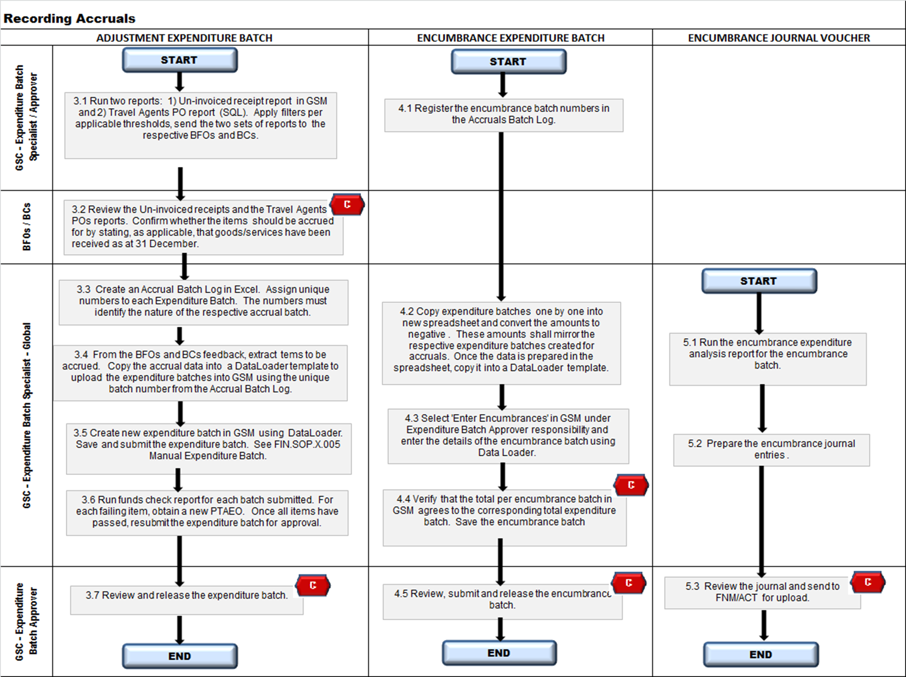
  - Process Flow: Record Adjustment to Expenditures

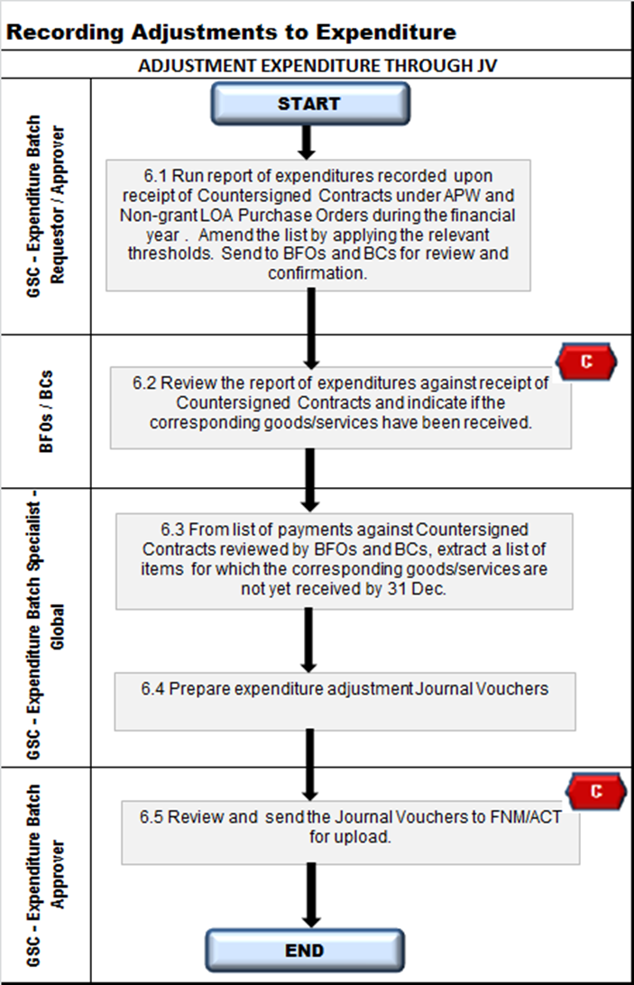
  - Process Flow: Reverse Accruals and Adjustments to Expenditure

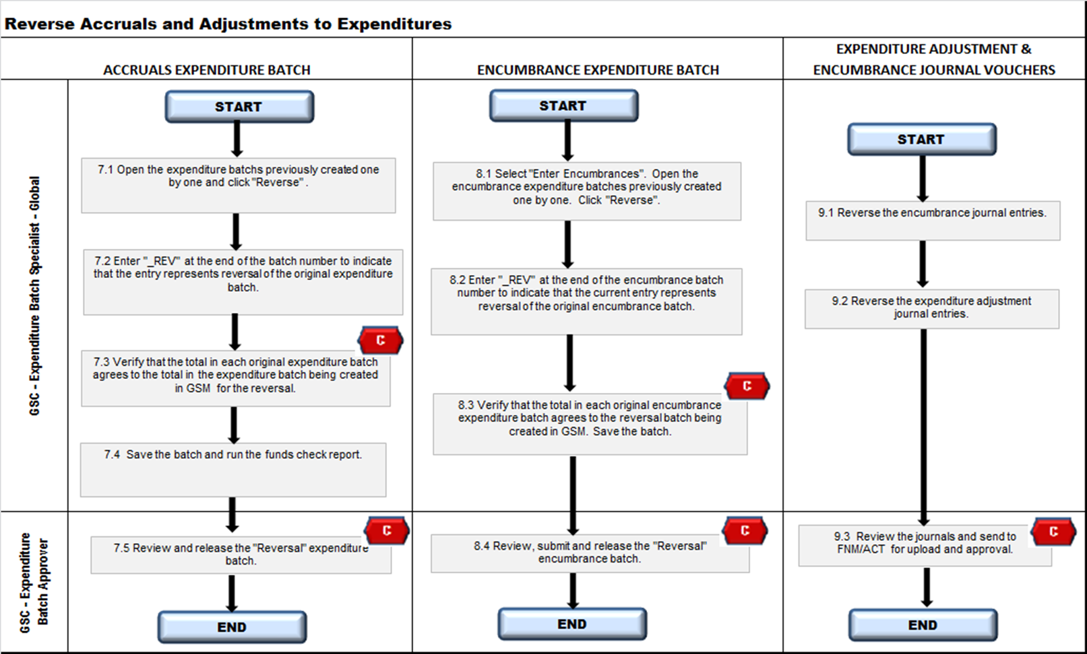
- PROCESS STEPS – RECORD ACCRUALS EXPENDITURE BATCH

Step | Control (C) | Type | Process | Role / Responsibility
3.1 |  | GSM - AP Inquiry and Reporting | Run two reports: 1) “Un-invoiced Receipts Report” in GSM and 2) Travel Agent PO report (SQL). Apply filters per applicable thresholds, and send the two sets of reports to the respective BFOs and BCs.  There are several filter options that GFI/GSC may select when running the Un-invoiced Receipts Accrual report. These include date filters and value ($) filters. Date filter options on the Un-invoiced Receipts Accrual report will vary depending on what period accruals are recognized for. For example, if accruals were recorded in July for reporting purposes, when recording accruals for December 31 of that same fiscal period, the filter option would only include data from August to December 31. The value selected depends on the dollar threshold established for recognizing receipt accruals. Refer to ‎1.2.3.  Exclude the following:  - Items that have been flagged as incorrect items by BCs during the monthly review process;  - Zero value items;  - Items that do not meet the threshold criteria (for year-end accruals)  Split the lists by Major Office, HQ Clusters and Entities in order to send two sets of reports to the respective BFOs and BCs for their review and confirmation. | GSC/GFI
 |  | Manual / SQL | The Travel Agent POs need to be run for those relating to Travel Requests (TRs) with departure dates of 01 October to 31 December.  - Filter the report to show only those TRs with fully unutilized balances  Apply further filter to include only TRs with the applicable threshold amounts | GSC/GFI
3.2 | C | Manual | Review the “Un-invoiced Receipts Accrual” and the Travel Agent POs reports. Confirm whether the item should be accrued for by stating, as applicable, that goods/services have been received as at 31 December. .  The confirmation shall be given by indicating:  - “Y” - to accrue because goods/services have been received by 31 Dec., or  - “N” - do not accrue because goods/services have not been received by 31 Dec.  Send the document back to GSC/GFI. | Regional Budget and Finance Officers and HQ Finance Officers
3.3 |  | Manual | Create an Accrual Batch Log in Excel. Assign unique numbers to each Expenditure Batch. The numbers must identify the nature of the respective accrual batch.  Expenditure batch numbers should include references to the organization (e.g. HQ), the year (e.g. 12), the reference to whether it is an accrual or an encumbrance accrual (e.g. ACC or ENC), and the batch number (e.g. 0001). For example, batch number AF/16/DEC16ACC_UIR_ACT0001 was used for accruals originating from Un-invoiced Receipts (UIR) relating to the African Region in 2016. Similarly a batch number AF/16/DEC16ACC_UIR_ENC0001 was used for the corresponding encumbrance batch. | GSC/GFI
3.4 |  | Manual | From the BFOs and BCs feedback, extract items to be accrued. Copy the accrual data into a DataLoader template to upload the expenditure batches into GSM using the unique batch number from the Accrual Batch Log.  Extract a list (spreadsheet) containing only those un-invoiced receipts and Travel Agent PO items confirmed for accruals by BFOs/BCs.  Copy the relevant data elements (Expenditure item date, amount, PTAEOs, comments) into a DataLoader template.
3.5 |  | GSM - Expenditure Batch – Specialist Global | Create a new Expenditure Batch in GSM using DataLoader. Save and submit the expenditure batch.  Refer to “FIN.SOP.X.005 Manual Expenditure Batch” for a step by step guide on creating, approving and releasing expenditure batches in GSM.  Ensure that items to be accrued do not include expenditure types 501, 502, 503 as these expenditure types relate to personnel costs and should not form part of good and service accruals.  Prepare the expenditure batch data in a spreadsheet and copy it into a DataLoader template. To upload into GSM, select “Expenditure Batch” under “Expenditure Batch Specialist – Global” responsibility and enter the details as per the requirements of the Expenditure Batch screen. Ensure to enter 31 December for year-end accruals. If there are negative lines in the batch, check the box next to the text “All Negative Transactions Entered As Unmatched” | GSC/GFI
3.6 |  | GSM - Expenditure Batch – Specialist Global | Run the Funds Check Report for each batch submitted. For each item that fails, obtain a new PTAEO. Once all items have passed, re-submit the expenditure batch for approval.  The Funds Check Report indicates whether there are sufficient funds in the PTAEO to enter the accruals. If there are sufficient funds, the report will indicate that the PTAEO has “Passed”. If not, it will indicate “Failed”.  As the encumbrance batch will offset the accrual expenditure batch once it is processed (after the accrual expenditure batch has run), few items should “Fail” once the encumbrance batch is entered. Therefore, once both the accrual and encumbrance batch have been processed, the Funds Check Report should only indicate the PTAEO’s that have truly failed due to insufficient funds. These items should be followed up with those responsible.  Once the new information is received, enter a new PATEO for the accrual in question in the existing expenditure batch. The expenditure batch should then be re-saved, re-submitted, and the Funds Check Report run once again until all items indicate “Passed”. | GSC/GFI
3.7 | C | GSM - Expenditure Batch – Specialist Global | Review and release the expenditure batch.  Refer to “FIN.SOP.X.005 Manual Expenditure Batch” for a step by step guide on creating, approving and releasing expenditure batches in GSM. | GSC/GFI
- PROCESS STEPS – RECORD ENCUMBRANCES BATCH

Step | Control (C) | Type | Process | Role / Responsibility
4.1 |  | Manual | Register the Encumbrance Batch Numbers in the Accruals Batch Log  Encumbrance batch numbers should include references to the organization (e.g. HQ), the year (e.g. 12), the reference to whether it is an accrual or an encumbrance (e.g. ENC), and the batch number (e.g. 0001). For example, batch number AF/16/DEC16ACC_UIR_EN0001 was used for encumbrances originating from the African Region in 2016. | GSC/GFI
4.2 |  | Manual | Copy the Expenditure Batch one by one into new spreadsheet and convert the amounts to negative. These amounts shall mirror the respective expenditure batches created for accruals. Once the data is prepared in the spreadsheet, copy it into a DataLoader template. | GSC/GFI
4.3 |  | GSM - Expenditure Batch Approver – Global | Select “enter encumbrances” in GSM under Expenditure Batch Approver responsibility and enter the details of the encumbrance batch using DataLoader.  Encumbrance batch may be either manually entered (e.g. for low volume transaction with 1-5 lines) or uploaded using DataLoader. Include the following information in the batch:  - Batch number: Enter the number  - Ending date: Enter the last working day of the period  - Description: Enter Miscellaneous Transactions  - Select: All Negative Transactions Entered As Unmatched | GSC/GFI
4.4 | C | GSM - Expenditure Batch Approver – Global | Verify that the total per the encumbrance batch in GSM agrees to the corresponding total expenditure batch. . Save and submit the encumbrance batch.  The values and PTAEO details entered will be identical to the ones entered for the accruals. However, all values will be negative (-) as we are crediting the PTAEO. The sum of all accrual expenditure batches and encumbrance batches should net to zero. | GSC/GFI
4.5 | C | GSM - Expenditure Batch Approver – Global | Review and release the encumbrance batch. | GSC/GFI

- PROCESS STEPS – RECORD ENCUMBRANCES JOURNAL VOUCHER

Step | Control (C) | Type | Process | Role / Responsibility
5.1 |  | GSM – Accounts Specialist - Global | Run the Encumbrance Expenditure Analysis Report for the encumbrance batch.  In the case of encumbrances, journal entries must be posted in GSM as the journals are not automatically generated via the encumbrance batch.  The Encumbrance Expenditure Analysis Report provides the account combination by expenditure type for the encumbrance batch in order to generate the journal entry. This information is then entered in the Journal Voucher Template and uploaded to GSM. In the Journal Voucher Template, select the following:  Accounting date: Last day of the period  Currency: USD  Category: Miscellaneous  Source: Encumbrance  Encumbrance Type: Commitment
5.2 |  | GSM – Accounts Specialist - Global | Prepare the encumbrance journal entries.  Journal entries must indicate details on the Major Office, Fund, Strategy, and Budget Centre. The following journal should be posted for each encumbrance batch:  Dr. 299001 Reserve for Encumbrance  Cr. 5xxxxxx (expenditure type)  The credit will go to an account(s) corresponding to the expenditure type as indicated by the BFO’s and BCs within the batch.  Refer to “FIN.SOP.XII.006 General Ledger Journal Vouchers” for step by step instructions on the use of journal voucher templates and recording journals in GSM. | GSC/GFI
  ACTIVITY COSTS
  511001 | Direct Financial Cooperation
  512001 | Consulting, Research Services
  513001 | Contractual Services, General
  514001 | Medical Supplies and Literature
  515001 | Equipment, Vehicles and Furniture
  516001 | Fellowships, GEA
  517001 | Training
  518001 | Travel
  519001 | General Operating Costs
  520001 | Telecommunications
  521001 | Hospitality Allowance
  522001 | Supplies in Kind
  523001 | Assets in Kind
  524001 | Security Expenses
  525001 | SSA Costs
  526001 | Letters of Agreement
5.3 | C | GSM – Expenditure Batch Specialist - Global | Review and send to FNM/ACT for upload and approval of the encumbrance journal entries. | GSC/GFI

- PROCESS STEPS – CREATE EXPENDITURE ADJUSTMENT JOURNAL

Step | Control (C) | Type | Process | Role / Responsibility
6.1 |  | Manual | Run report of expenditures recorded upon receipt of Countersigned Contracts under APW and Non-grant LOA Purchase Orders during the financial year. Amend the list by applying the thresholds for such adjustments stipulated in this SOP. Send to BFOs and BCs for review and confirmation.  Run a report of invoices against Countersigned Contracts recorded during the year and filter out items not to be reviewed using the applicable thresholds; | GSC/GFI
6.2 | C | Manual | Review the report of expenditures against Countersigned Contracts and indicate if the corresponding goods/services have been received.  If goods/services have not been received by 31 Dec, indicate “Y” to confirm that adjustment is needed;  If goods/services have been received by 31 Dec, indicate “N” to confirm that no adjustment is needed as the recorded expenditure is correct. | Regional Budget and Finance Officers and HQ Finance Officers
6.3 |  | Manual | From list of payments against Countersigned Contracts reviewed by BFOs and BCs, extract a list of items for which the corresponding goods/services are not yet received by 31 Dec.  These are items confirmed as “Y” in the above step. | GSC/GFI
6.4 |  | Manual | Prepare expenditure adjustment Journal Vouchers  Please use the most current template for Journal Vouchers.
6.5 | C | Manual | Review and send the Journal Vouchers to FNM/ACT for upload.

- PROCESS STEPS – REVERSE ACCRUALS EXPENDITURE BATCH

Step | Control (C) | Type | Process | Role / Responsibility
7.1 |  | GSM - Expenditure Batch – Specialist Global | Open the expenditure batch previously created one by one and click “Reverse”. | GSC/GFI
7.2 |  | GSM - Expenditure Batch – Specialist Global | In the “Reverse Accrual Expenditure Batch”, enter the original batch number.  Enter “_REV” at the end of the batch to indicate that the current entry represents reversal of the original expenditure batch.  (E.g. AF/16/DEC16ACC_UIR_ACT0001_REV) | GSC/GFI
7.3 | C | GSM - Expenditure Batch – Specialist Global | Verify that the total in the original expenditure batch agrees to the total in the expenditure batch being created GSM for the reversal.  Ensure the All Negative Transactions Entered As Unmatched is selected. There is no need to change the date as the system will automatically use the current date when reversing the batch. | GSC/GFI
7.4 |  | GSM - Expenditure Batch – Specialist Global | Save the batch and run the Funds Check Report.  Follow up as done in step 3.5 with any PTAEO’s that fail the Funds Check Report. | GSC/GFI
7.5 | C | GSM - Expenditure Batch – Approver Global | Review and release the “Reversal” expenditure batch.  Refer to “FIN.SOP.X.005 Manual Expenditure Batch” for a step by step guide on approving and releasing expenditure batches in GSM. | GSC/GFI

- PROCESS STEPS – REVERSE ENCUMBRANCES BATCH

Step | Control (C) | Type | Process | Role / Responsibility
8.1 |  | GSM - Encumbrance Batch Specialist – Global | Select “Enter Encumbrances”. Open the encumbrance batch previously created and click “Reverse” . | GSC/GFI
8.2 |  | GSM - Encumbrance Batch Specialist | In the “Reverse Encumbrance Batch”, enter the original batch number.  Enter “_REV” at the end of the encumbrance batch number to indicate the current entry represents reversal of the original encumbrance batch.  (AF/16/DEC16ACC_UIR_ENC0001_REV) | GSC/GFI
8.3 | C | GSM – Encumbrance Batch Specialist | Verify that the total in each original encumbrance batch agrees to the total in the encumbrance batch being created in GSM for the reversal. Save the batch.  Ensure the All Negative Transactions Entered As Unmatched is selected. There is no need to change the date as the system will automatically use the current date when reversing the batch. | GSC/GFI
8.4 | C | GSM - Expenditure Batch Approver – Global | Review, submit and release the “Reversal” encumbrance batch. | GSC/GFI

- PROCESS STEPS – REVERSE ENCUMBRANCES JOURNAL VOUCHER

Step | Control (C) | Type | Process | Role / Responsibility
9.1 |  | GSM – Encumbrance Batch Specialist | Reverse the encumbrance journal entries.  The encumbrance journal entries recorded in GSM must also be reversed in the subsequent period. To do so, in GSM, open the original encumbrance journal entry, select reverse and approve. The following reversal entry is posted:  Dr. 5xxxxxx (expenditure type)  Cr. 299001 Reserve for Encumbrance | GSC/GFI
9.2 |  | GSM – Encumbrance Batch Specialist | 9.2 Reverse the expenditure adjustment journal entries.
9.3 | C | GSM – Encumbrance Batch Specialist | Review the journals and send to FNM/ACT for upload and approval | GSC/GFI

- KEY RISKS & COMPENSATING CONTROLS

Risks | Compensating Controls | Process Step
Misstatement of financial statements due to processing of erroneous journal vouchers or expenditure batches (JVs duplicated, JV entered to a control account, incorrect currency etc.) | The Global Finance Service Manager in GSC/GFI reviews the journal vouchers prior to releasing the batches and posting the journal entry.  In addition, any errors will be picked up in accounts review by the account holder and account reconciliations. | 3.7/4.5/5.3/7.3/7.5/8.3/8.4
Misrepresentation of financial statements due to incorrect accounting and use of the Manual Expenditure batch. | BFOs and BCs verify that PTAEO information is correct.  The Global Finance Service Manager in GSC/GFI reviews the Journal Voucher and expenditure batches prior to posting. | 3.2  3.7/4.5/5.3/7.3/7.5/8.3/8.4/9.3
Accruals are overstated/understated due to: 1) items being accrued that should not be or 2) items that should be accrued are not identified. | BFOs and BCs verify accrual data for correctness before submitting the data to GSC/GFI. | 3.2
Data entry errors by users in the receipt process. | BFOs and BCs verify accrual data for correctness before submitting the data to GSC/GFI. | 3.2
Expenses are overstated because of those items recorded against receipt of Countersigned Contracts rather than actual goods/services. | BFOs and BCs verify expenses against Countersigned Contracts | 6.2
Due to timing differences between the release of the expenditure batch and the encumbrance expenditure batch (both for the original expenditure batch and the subsequent reversal), PTAEO’s may appear to have “additional funds” momentarily. | Expenditure batches for accruals and encumbrances should be released and approved together. No delays should occur between approving and releasing both items.  BFO’s/BCs are responsible for ensuring sufficient funds exist in the PTAEO and funds are not overspent. | N/A

Annex I

Contract types and justification for year-end adjustments to related expenditures:

Contract Type | Included | Excluded | Explanation
Agreement for Performance of Work/ Agreement for Performance of Work - Emergency | X |  | APWs are used to finalize contracts for services such as the writing of an article or report, the translation and editing of documents, the conduct of surveys/interviews to collect data on certain health related issues, etc.  As the service to be received is obtained at the end of the contract, any amounts paid in advance of the receipt of the final deliverable should be recorded as a prepayment.
Direct Financial Cooperation |  | X | DFC payments are payments to member states or member state approved organizations for achieving agreed objectives. When WHO makes the payment to the national counterpart, WHO no longer has control over the funds as the counterpart is fully responsible for performing the activities required to achieve the objectives. DFCs are therefore expensed upon payment and not considered advances/prepayments.
Consultant/Consultant - Emergency | X  Amount based | X  Rate based | Rate based consultancy contracts, deliverables are normally equated to the time spent and receipting is usually carried out in stages during the duration of the contract similar to staff contracts allowing expenses to be are therefore progressively recognized as the stages are completed. These are not considered for advances/prepayments.  For amount based Consultant contracts, however, there could be deliverables set as and paid against ‘receipt of countersigned contract’. These are considered advances/prepayments if delivery of actual service/work does not occur.
Letter of Agreement | X  Non-grant LOA | X  Grant LOA | Letters of Agreement are typically the funding mechanism for GRANTS, in which WHO acts as a funding agency, rather than commissioning its own work, with terms and conditions defined in a signed letter.  As such, payments of this nature are treated as grants and payments to implementing partners are expensed in the year in which the amounts are paid as WHO does not have control or ownership of the related service.
Technical Service Agreement |  | X | A Technical Services Agreement (TSA) is used for the performance of research (e.g. preclinical and clinical studies) or other technical services (e.g. the screening and testing of compounds) to be performed by an Institution under contract with WHO.  TSAs are considered to be GRANTS, and are treated like LOAs, where payments are expensed in the year in which the amounts are paid as WHO does not have control or ownership of the related service.

